Project Development Phase
Flow Designer Model Performance Test
Date | 29 September 2026
Team ID | SWTID-2026-9791
Project Name | Streamlining IT Procurement: Automating Standard Laptop Orders with Flow Designer
Maximum Marks | 10 Marks
Team Size | 3
Team Leader | MONIKA S
Team Member | PREETHA S
Team Member | RANJANI DEVI M

Model Performance Testing:
Project team shall fill the following information in model performance testing template.
S.No. | Parameter | Values | Screenshot
1 | Workflow Automation Metrics | Successful Order Execution: Verified that standard laptop catalog requests trigger Flow Designer automatically.  Approval Accuracy: Manager approval requests are correctly routed based on user profile.  Fulfillment Efficiency: Automated generation of SCTASK for IT provisioning and imaging. | 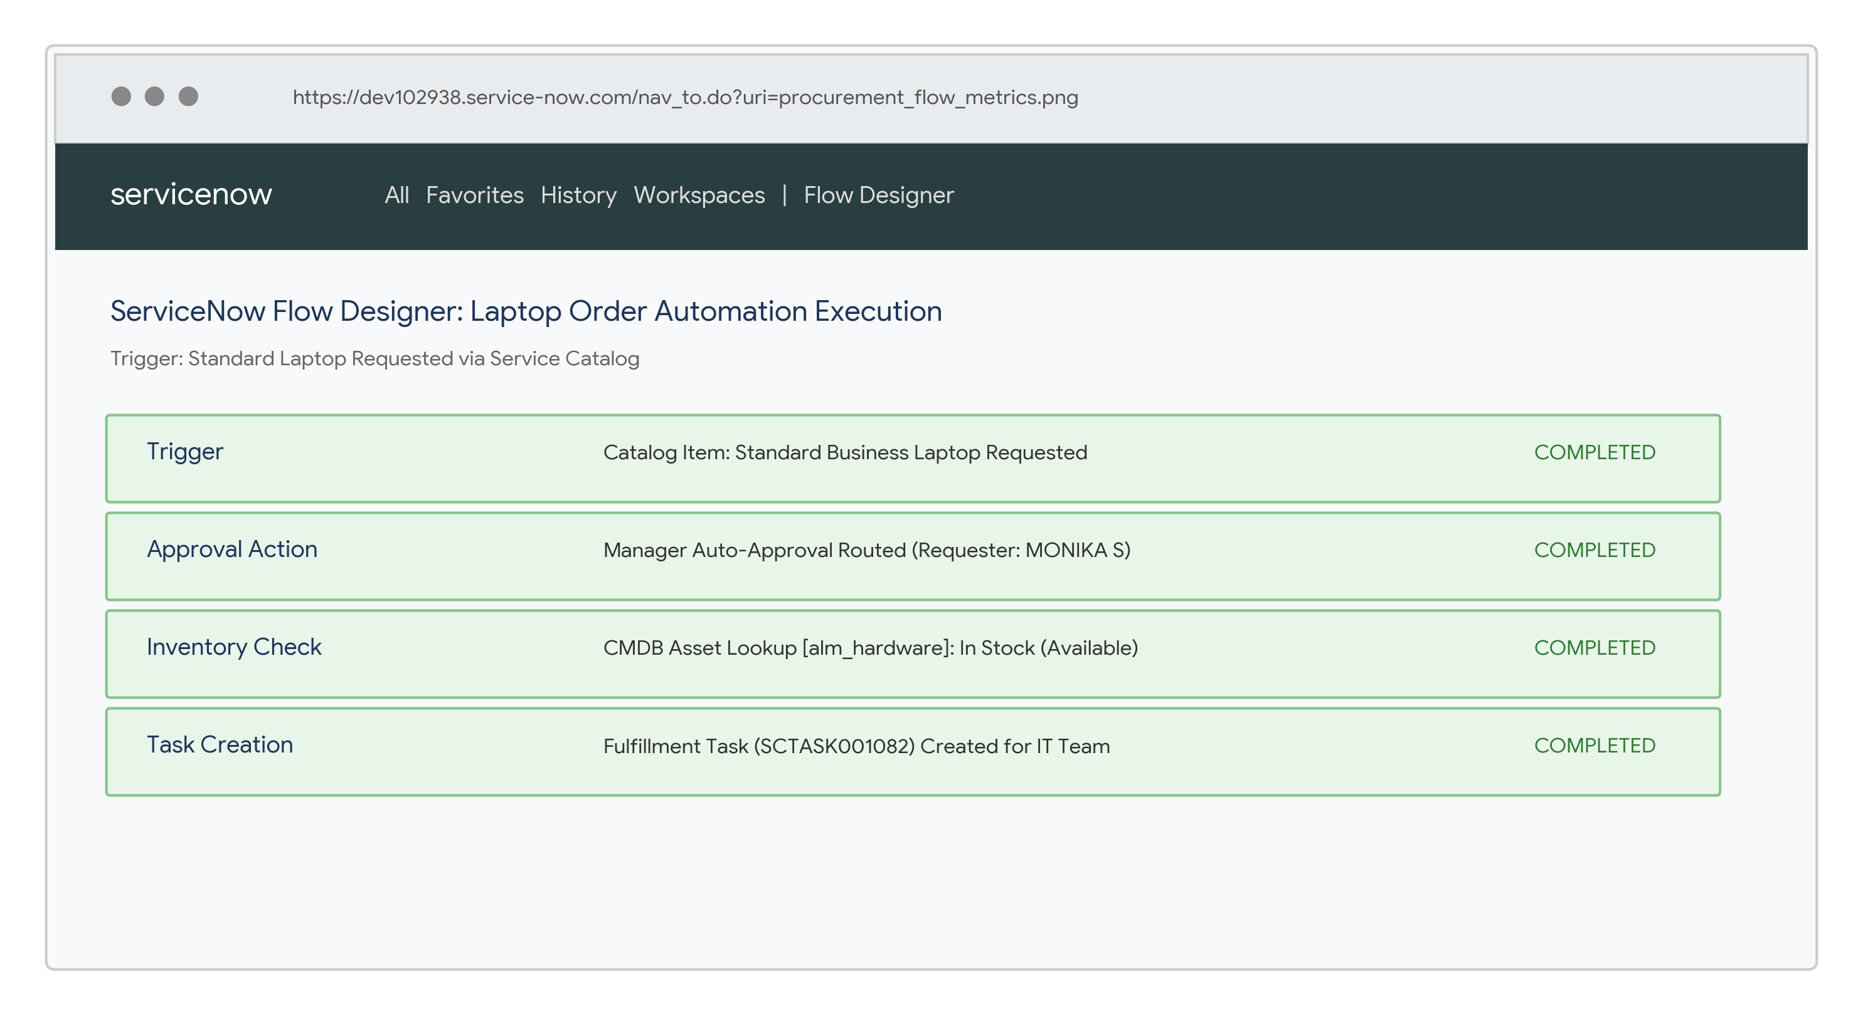
2 | Flow Rule Validation | Inventory Check: Validated CMDB stock availability before triggering fulfillment tasks.  Subflow Execution: Verified status email notifications and SLA time tracking.  Exception Handling: Handled out-of-stock and missing manager scenarios gracefully without stuck states. | 